Activity 6.2: Create an impossible creature
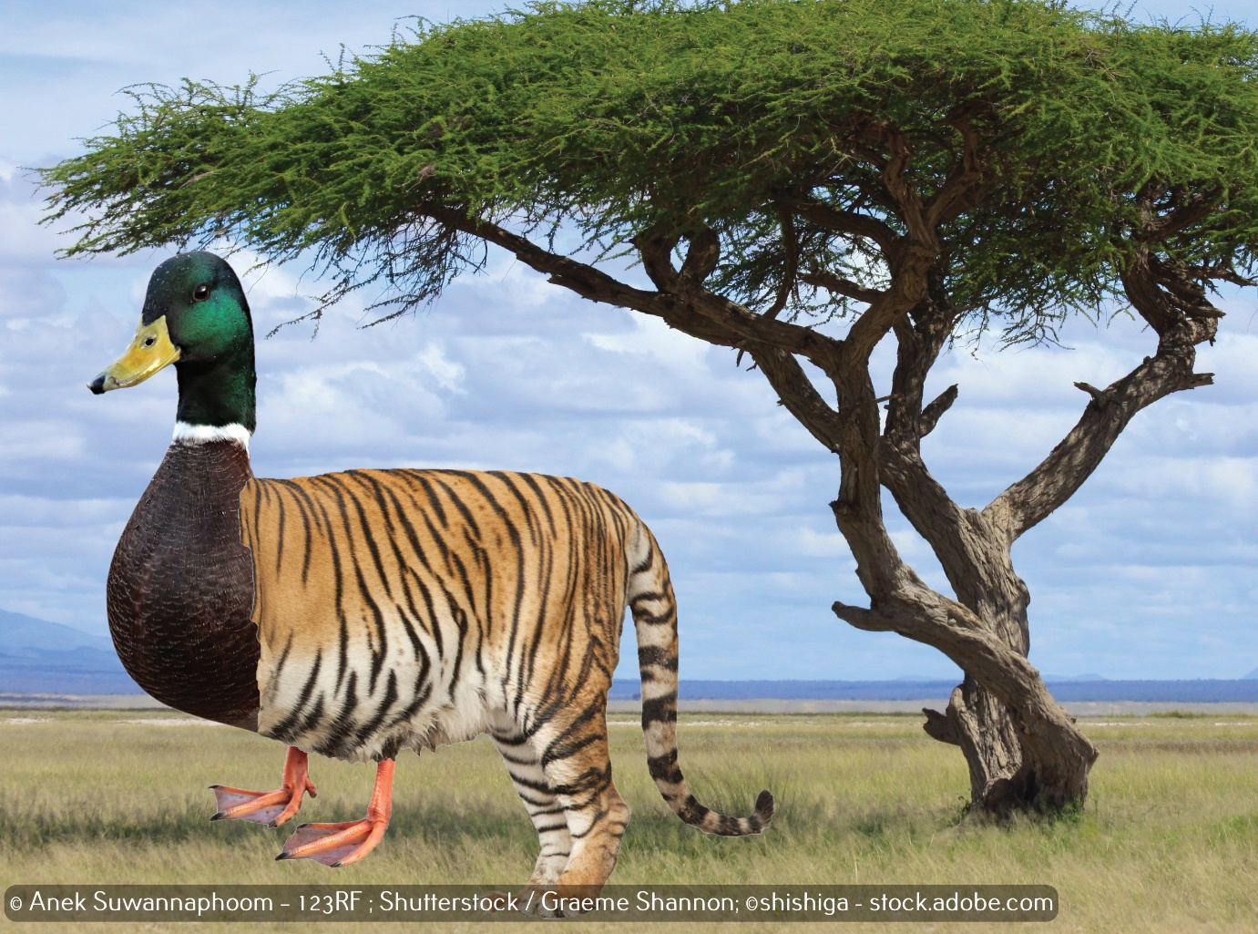
Your final challenge is to use your image editing skills to create an impossible creature, like the one above.
You will need to use the ‘Rectangle Select Tool’ to select part of each animal.
You will need to use the ‘Scale Tool’ to match the parts of the two animals together.

